

Processing Report

By:

phomi

Table of Contents

1 Imported Data 2

1.1 Directory 2

1.2 Properties 2

1.3 Display the selected frame 2

2 Pre-Processing 3

2.1 Cropping the image 3

2.2 DC offset removal 3

2.3 Image filtering 3

3 Phase Extraction 3

4 Post-Processing 3

4.1 Masking 3

4.2 Denoising 3

4.3 Phase unwrapping 3

4.4 Background removal 3

4.5 Image enhancement 3

1. Imported Data
   1. Directory

File full path: C:\Users\phomi\Desktop\Projects\software\PhaseRetrievalAPP\120nm_4.tif

* 1. Properties

Size of the input: 2048 2048

* 1. Display the selected frame

**Frame number:** 1

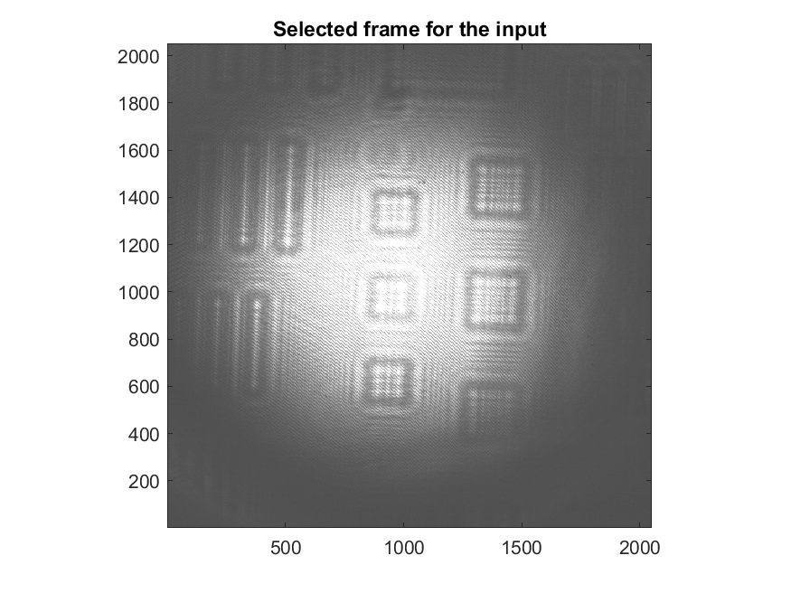

1. Pre-Processing
   1. Cropping the image

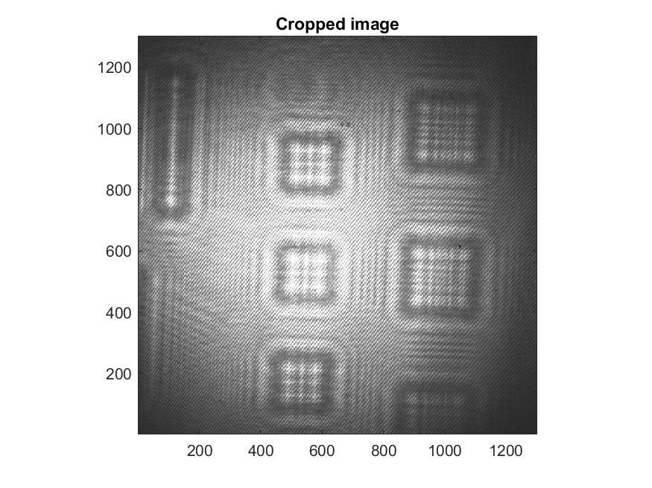

* 1. DC offset removal

**Method:** Gaussian Spatial

|  |  |
| --- | --- |
|  |  |
|  |  |

* 1. Image filtering

**Denoising:**

|  |
| --- |
| No denoising filter is applied |

**Contrast Enhancement Method:**

Original

|  |  |
| --- | --- |
|  |  |

1. Phase Extraction

|  |  |
| --- | --- |
| System: | Off-axis Interferometry |
| Algorithm: | Discrete Fresnel Transformation |
| Algorithm Parameters: |  |
| Camera pixel size (um) = | 3.5 |
| Laser wavelength (nm) = | 633 |
| Reconstruction Zero Padding Size (pixel) = | 4096 |
| Filter radious (pixel) = | 1024 |
| Object Plane-Imaging Plane Distance (cm) = | from 50 , interval 0 ,to0 |
| Wrapping Zero Padding Size (pixel) = | 4096 |
| Window Size (Radius) = | 1024 |
| Frequency Filter Type = | Gaussian |
| Frequency Filter Size = | 400 |

|  |  |  |
| --- | --- | --- |
|  |  |  |

1. Post-Processing

|  |  |
| --- | --- |
| Selected Phase Map = | Carrier Removed Wrapped Phase |

* 1. Denoising

|  |
| --- |
| No denoising filter is applied |

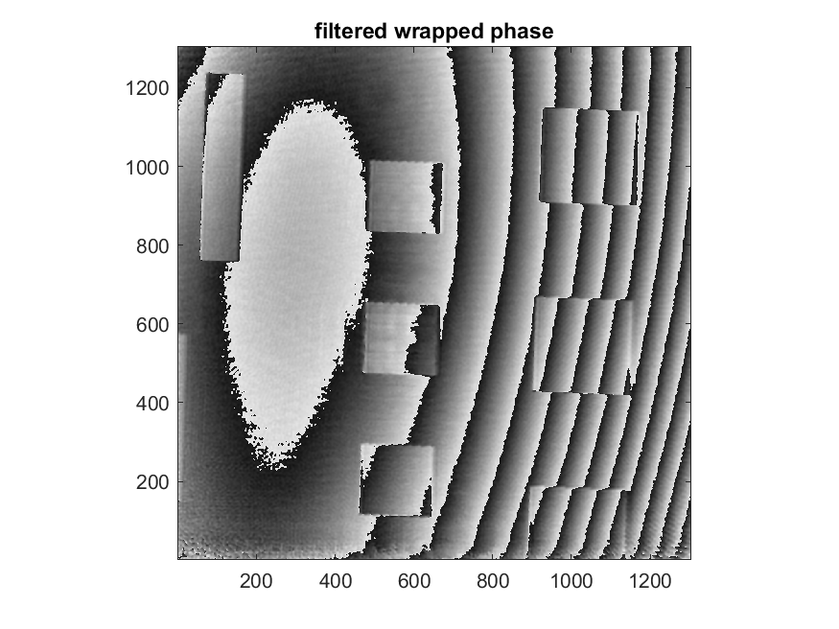

* 1. Masking

|  |
| --- |
| No Mask has been picked |

* 1. Phase unwrapping

|  |  |
| --- | --- |
| Unwrapping Algorithm = | Constantin |
| Using Mask = | No |

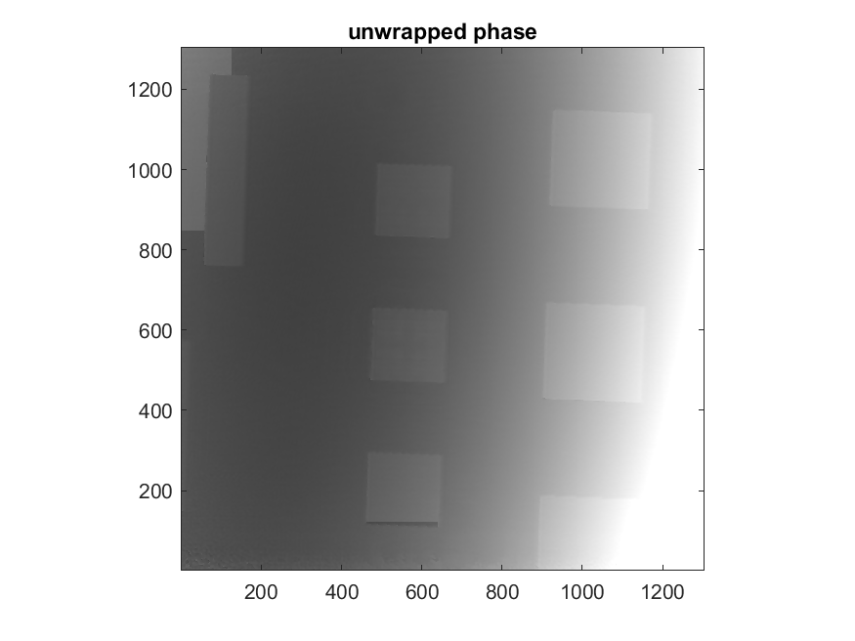

* 1. Background removal

Automatic background estimation

|  |  |
| --- | --- |
|  |  |

* 1. Image enhancement

|  |
| --- |
| No denoising filter is applied |

